|  |
| --- |
| Aston Technologies Inc. |
| Cisco Security Lab -Windows Services and Windows Hosts |
| An Aston training document stepping through deploying our hosts needed for the Cisco security labs |

Contents

Contents 2

Introduction 3

Deploy Windows Machines 4

Configure Windows Machines 9

Conclusion 18

Introduction

This lab we are going to deploy 4 Windows machines. A Windows 2016 server with Active Directory, Certificate Authority and DNS services already installed. Then we will deploy 3 Windows 10 hosts that we will use to test our policies in the upcoming labs.

Ideally you should use the vcenter management interface at <https://dc-isevcen.astontech.com/> to operate everything in the lab but if you have a requirement to access any of the lab devices directly from Astons internal network, you can use the IP table below.

|  |  |  |  |  |
| --- | --- | --- | --- | --- |
|  | LAB 1 | LAB 2 | LAB 3 | LAB 4 |
| ACCESS-SW (MGMT) | 10.8.1.35 | 10.8.1.40 | 10.8.1.42 | 10.8.1.44 |
| CORE-SW (MGMT) | 10.8.1.36 | 10.8.1.41 | 10.8.1.43 | 10.8.1.45 |
| ASA (outside) | 10.8.1.2 | 10.8.1.66 | 10.8.1.98 | 10.8.1.130 |
| Jumphost (RDP) | 10.8.1.5 | 10.8.1.69 | 10.8.1.101 | 10.8.1.133 |
| FTD (outside) | 10.8.1.10 (P)  10.8.1.11 (S) | 10.8.1.75 (P)  10.8.1.76 (S) | 10.8.1.105 (P)  10.8.1.106 (S) | 10.8.1.135 (P)  10.8.1.136 (S) |

Deploy Windows Machines

Open the vCenter management interface at <https://dc-isevcen.astontech.com/> and sign in with your **Aston** **AD** credentials. Contact a mentor or escalation engineer if permissions are required.

Once signed in click the icon in the image below bring up the **VMs and Templates** view. Expand the templates folder for the lab you are working in. There is a folder for lab 1 and a folder for lab 2-4. Right Click on **ISE-AD SERVER TEMPLATE** and select **New VM Machine from this Template**.

Name it **YOUR-NAME AD SERVER** and put it in thecorresponding VM folder. Then hit **Next**.

VMs for lab 1 go in **esximnise-1.astontech.com** and VMs for the rest go in **esximnise-2.astontech.com** then hit **Next**.

Put it in one of the **VM-datastores** **1** or **2** which ever has the most space and hit **Next**. Labs 2-4 will have only one datastore option.

Select **Customize this virtual machine’s hardware** and hit **Next**.

Change **Network adapter 1** to the MGMT subnet in the corresponding lab number.

Then hit **Next** and **Finish**.

Now right click on the **ISE-PC-TEMPLATE** and select **New VM from this Template**. Name it **YOUR Name PC-1** and put it in the **LAB X VMs** folder. Then hit **Next**.

Select the proper ESXi host(1 for lab 1 and 2 for the rest) and hit **Next**

Put it in one of the **VM-datastores** **1** or **2** whichever has the most space and hit **Next**.

Select **Customize this virtual machine’s hardware** and hit **Next**.

Assign Network adapter 1 to the MGMT SUBNET of the proper lab pod then hit **Next** and **Finish**.

Now create two more PCs named **YOUR NAME PC-2** and **YOUR NAME PC-3** follow the same process we just completed.

Configure Windows Machines

Once the Windows Server is been deployed open a console window and log in with **Administrator qwe123$!**. Active Directory, DNS, CA and GPO has already been configured for you. Create a user for yourself. Make your user a Member Of the following groups – **BYOD-Users, Domain Admins, Employee, Network Admins** and **Sponsor**.

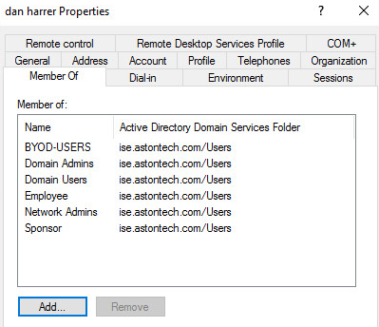

Now open a console window to PC-1. Log in with **admin qwe123$!**. Hit the **Windows** icon and type **PC**. Then Right click and select **Properties**.

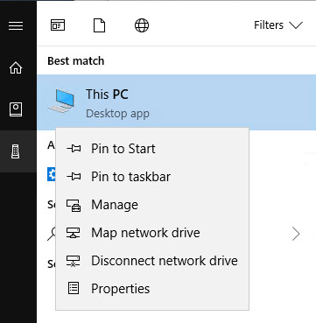

Hit **Change Settings**.

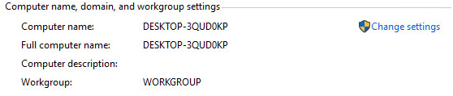

Hit **Change**.

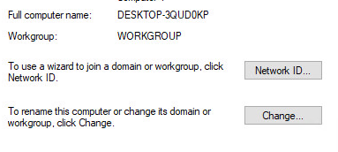

Name it **PC-1**.

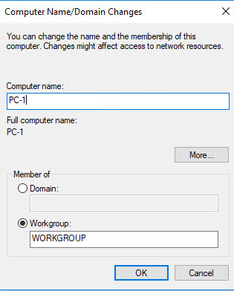

**Restart** the VM.

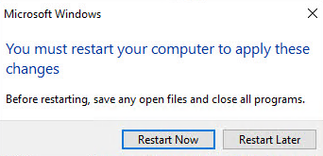

Do the same thing for **PC-2** and **PC-3**.

Once that is complete, open the console window to PC-1 again. Click on the **Windows** icon and type **PC**. Then right click on it and go to **Properties**.

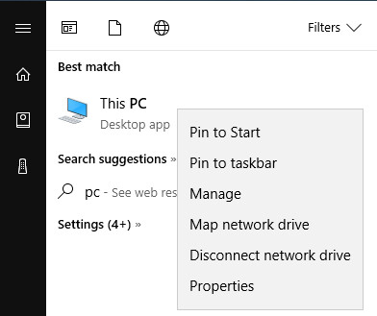

Add the PC to the domain. Under Computer name, domain and workgroup settings hit **Change settings**.

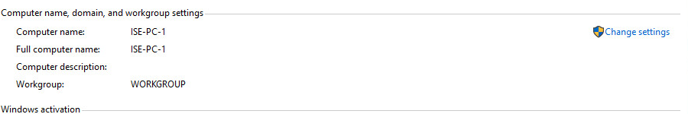

Hit the **Change** button on the next window.

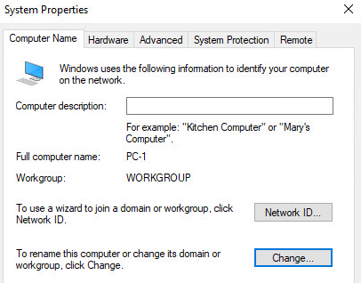

Hit the **Domain** radio button and type **ise.astontech.com** in the window then hit **OK**.

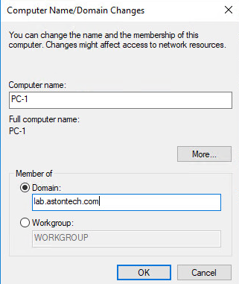

Use the **Administrator** account and password **qwe123$!** to join the domain.

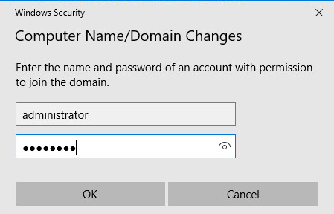

You should see the Welcome message. Hit **OK**, **Ok** then **Close**.

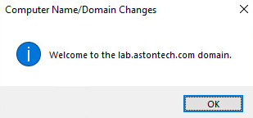

Then **Restart Now**.

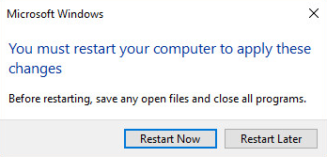

Now **PC-1** should be joined to the domain. Do the same thing for **PC-2** but **not** for **PC-3**.

After the reboot sign in with your AD account for PC-1 and PC-2. Click **Other User** then sign in.

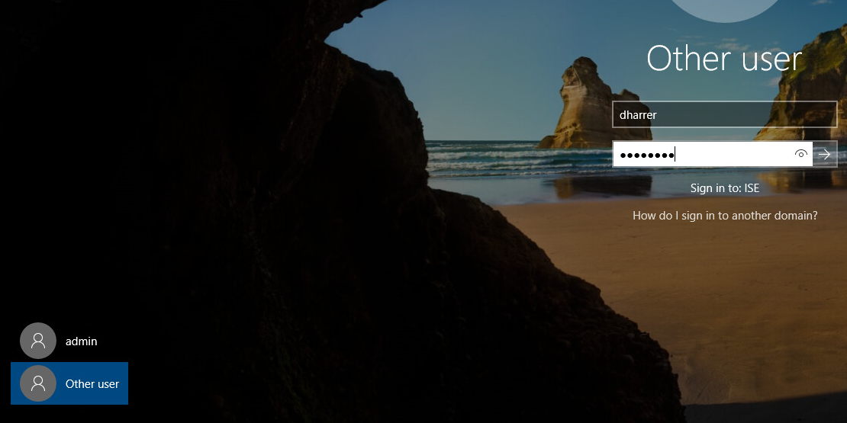

Let’s check to see if the Certs were issued. Open the console window for the 2016 server. Open the **Start Menu** and click on **Windows Administrative tools**.

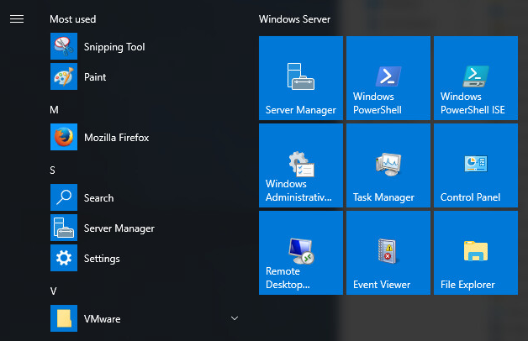

Then click **Certification Authority** then expand **ise-AD-DC-CA** and click on **Issued Certificates**. You should see a cert for PC-1 and PC-2 and two for yourself.

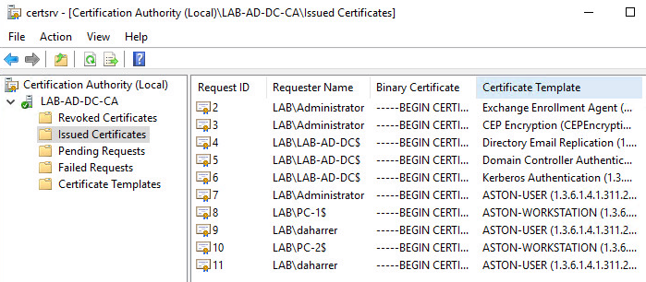

Before we wrap up this lab move PC-1 from the MGMT network to LAB (x) Access-SW G1/0/8.

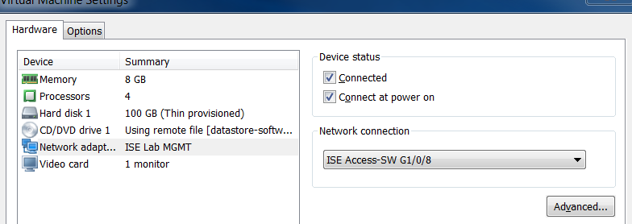

Conclusion

In this lab, we have:

* Deployed a Windows 2016 server from a template
* Deployed three Windows 10 hosts from a template
* Added ourselves a user in Active Directory and applied group membership
* Joined ISE-PC-1 and ISE-PC2 to the domain
* Verified that the certificates were issued from the CA

In the next lab, we are going to bootstrap our ISE host and make some tweaks to the initial configuration.